Auto Configuration Server (ACS) TR-069 management software platform that manages and monitors devices over any network. Greater insight into the in-home network and other services allows you to deliver preemptive support, measure service quality and speed, as well as improve customer experience and QoE, all while driving cost reductions with greater operational efficiency.
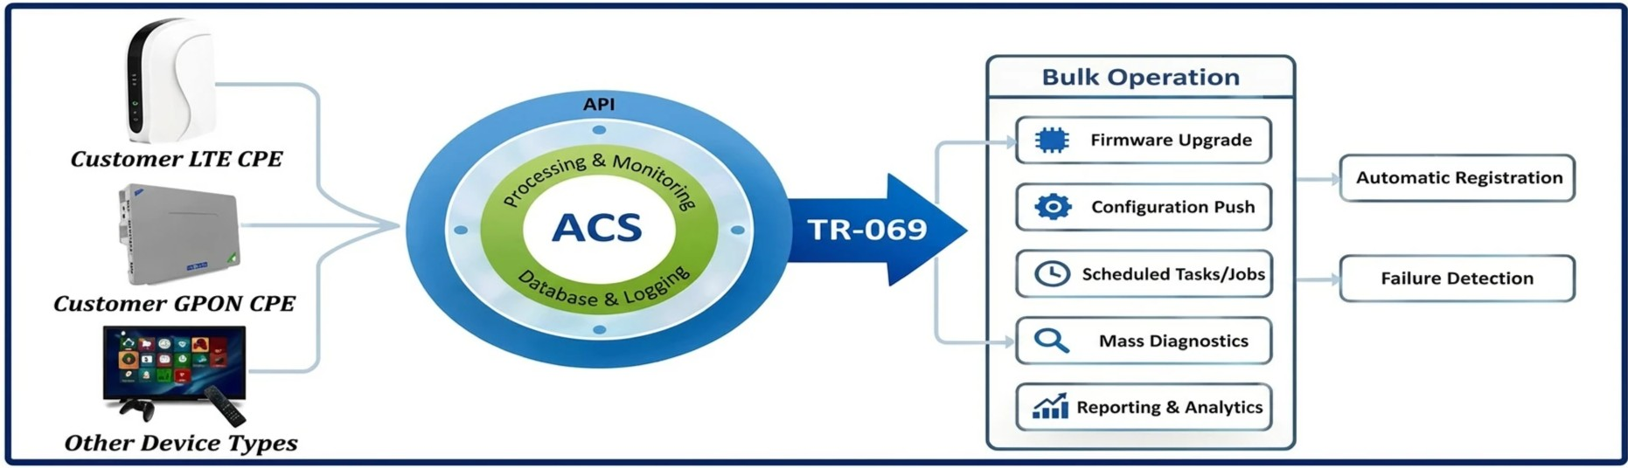
Benefits of ACS Platform
Simplify device provisioning and lifecycle management with advanced troubleshooting, device monitoring, and bulk operation capabilities that avoid truck rolls and reduce operational costs.
- Increasing of customers loyalty
- Displaying device failures in real time
- Grouping network terminals to control and update several devices simultaneously
- Devices automatic registration
- Easily perform bulk operations, such as firmware updates, client reboots, or parameter changes.
- Monitor and diagnose devices for pre-emptive support and advanced troubleshooting
- Automatic detection of new devices (zero-touch configuration)
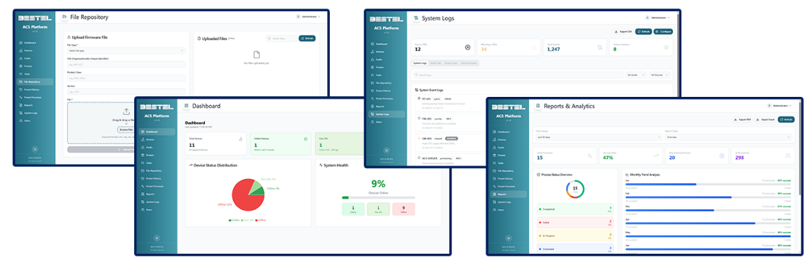
- It also allows connection of third-party devices, which fully support TR-069 specification and have been tested for compatibility.

Specifications
- DSL Forum TR-069, TR-157, TR-181, TR-098, TR-143, TR-111
- SSL 3.0 / TLS 1.0 ．
- HTTP 1.1, SOAP 1



crikleco ACS FEATURES

Performance Monitoring
Crikleco ACS collects CPE information and statistics generated by the TR-069 parameters for monitoring CPE status and performance. A status web page lists the most recent CPE parameter values reported to the ACS. CPE status information can be exported as a CSV file by CPE group or individually.

Detailed Logging
Every CPE connection record is logged in the Session Log. Moreover, the Crikleco ACS features Notification, Download, Bootstrap, and Error Logs. Any log entry can be exported or cleared from the log tables.

CPE Diagnostics
Crikleco ACS uses CPE information generated by TR-069 parameters to diagnose connectivity or service issues. For example, it can ask the CPE to ping an IP address or hostname and report the result of the ping test.
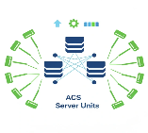
High Availability and Scalability
According to the design of our load balance model, multiple ACS can support thousands of CPE accounts with support for multiple upgrade and configuration tasks running simultaneously.

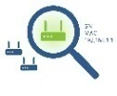
CPE Search by Keyword
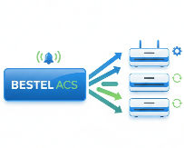
Crikleco ACS administrators can use keywords (MAC Address, WAN IP Address, S/N, CPE Group, Notes, and customer data) to search for a specific CPE or multiple CPEs. The Global Search function can search a CPE that may exist in any CPE Models.

ACS-Initiated Provisioning
At any time, the ACS can request that a CPE initiate a connection to the ACS using the Connection Request notification mechanism. By using the Connection Request, the Crikleco ACS can ask the CPE to reboot or restore CPE settings to the factory defaults. It can also send Grouping Connection Requests to all of the CPEs that belong to a certain CPE Group.
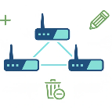

Batch Functions
ACS administrators can use the Batch Copy function or Batch Add function to simultaneously add many CPE accounts. The Batch Edit function can be used to update customer data and parameter values for groups of CPEs. Similarly, the Batch Delete function can be used to simultaneously delete multiple CPE accounts.

BT069p

