CKCRM is the command center for modern subscriber management. It transforms the support process by fusing critical subscriber data with live network insights into a single, powerful platform.This platform provides 360-degree view, where customer history, service plans, and device status are consolidated for immediate access. This unified perspective empowers operators to deliver faster, more accurate support, streamline complex workflows, and significantly enhance the customer experience—turning every interaction into an opportunity for loyalty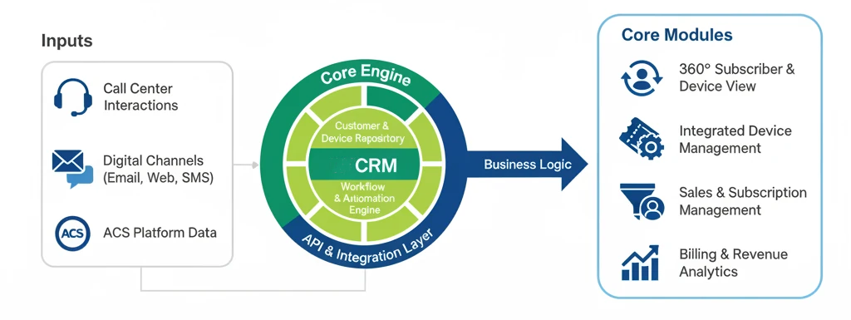BENEFITS OF ckCRM PLATFORM
CKCRM equips your operational teams with a definitive single source of truth. By centralizing subscriber profiles, essential device telemetry, and support ticketing into a unified “single pane of glass,” the platform transforms complex operational data into clear, actionable intelligence. This empowers your Level 1 support to resolve issues faster, operate with greater accuracy, and deliver a consistently superior customer experience.
- Accelerate First-Call Resolution: Eliminate context switching by presenting a 360° customer view—including live device status, service history, and active tickets—directly within a single, integrated console.
- Streamline Support Workflows: Empower agents with an intuitive interface that simplifies ticket creation, management, and escalation. Integrated tools and quick actions reduce manual data entry and minimize handling times.
- Elevate the Customer Experience: Provide your support teams with the complete operational picture needed to offer faster, more accurate, and personalized support, building subscriber trust and long-term loyalty.
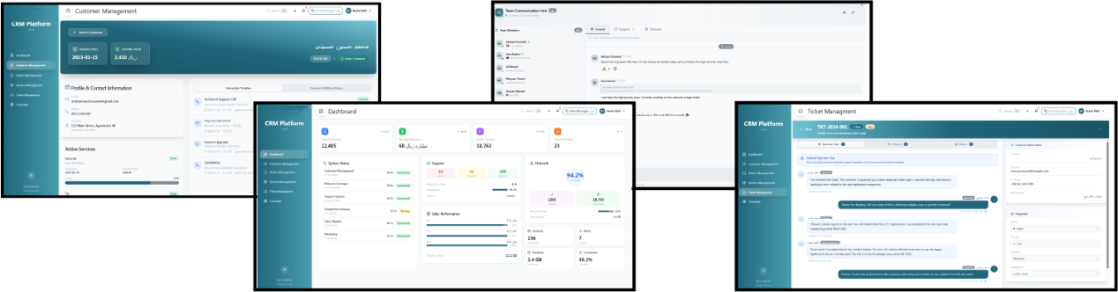
- in Real-Time Operational Visibility: Utilize the central dashboard to monitor key performance indicators at a glance, from ticket volumes and agent performance to network health alerts, enabling data-driven decision-making.

Specifications
• API & Integration: Fully-featured RESTful API (JSON) with Webhook support for real-time, event-driven integrations with third-party systems like ACS and payment gateways.
• Security & Compliance: Enterprise-grade security featuring Role-Based Access Control (RBAC), immutable audit trails for regulatory compliance, and a fraud detection engine.
• Core Architecture: Scalable, multi-module platform built on a responsive, role-aware design, ensuring a seamless user experience across all devices and operational roles.

ckcrm FEATURES

Dashboard
Gain immediate, high-level insight into your entire operation. The central dashboard provides a real-time snapshot of mission-critical KPIs, including subscriber counts, revenue, and network health, enabling your team to make informed, data-driven decisions from a single, unified view.

Customer Management

Unify all customer touchpoints into a single 360° profile. This module consolidates contact details, active subscriptions, device information, and a complete interaction history, empowering your teams with the immediate context required to deliver exceptional and personalized service.

Device Management
Integrate network device oversight directly into the CRM workflow. Monitor real-time device status and access critical ACS telemetry from within the customer profile, eliminating the need for separate consoles and accelerating technical troubleshooting.



Product Management

Centralize and manage your complete portfolio of service plans and product offerings. This module acts as the definitive catalog for your business, ensuring consistency across sales, billing, and provisioning while simplifying the management of your commercial offerings.

Support & Ticketing
Streamline your entire support lifecycle with an integrated ticketing system. Each ticket provides a “Single Pane of Glass” view, automatically enriched with full customer and device context. This allows agents to diagnose, track, and resolve issues with greater speed and efficiency.

Team Communication
Enhance internal collaboration with a secure, built-in communication. Create dedicated channels for teams and projects, enabling real-time information sharing and problem-solving. This feature centralizes all internal dialogue, eliminating the need for third-party messaging applications.
CKCRM

