Specification
Advanced LTE WiFi Gigabit Router
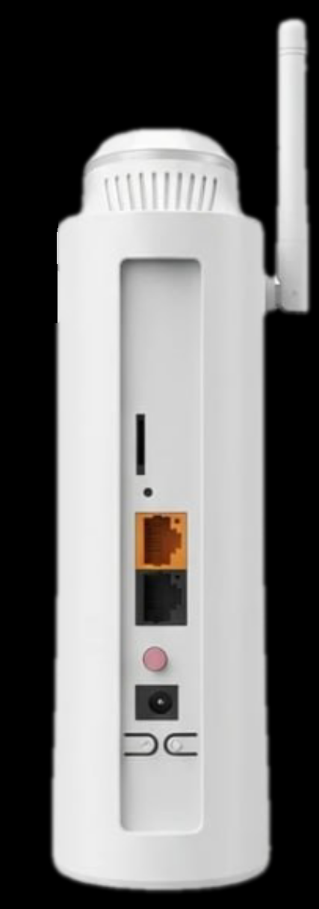
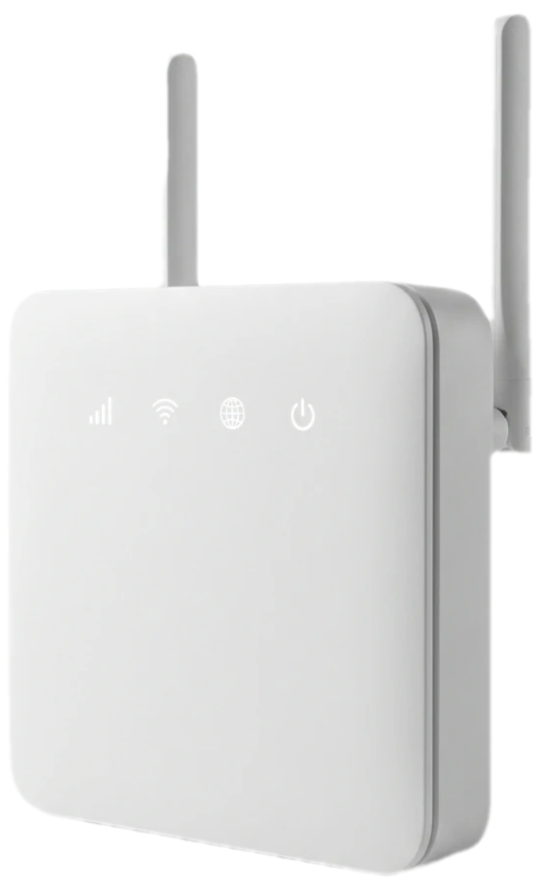
Plug & Play

Model: CK122i

2CA 4x4 MIMO & 3CA / 4CA 2X2 MIMO
B L A C K T O R N A D O

Maintenance – Free Connections


Introduction

LTE (Long Term Evolution) is already gaining momentum as the world’s most rapidly deployed cellular technology, giving mobile wireless broadband services to millions of users worldwide. Consumers are increasingly looking for always on, always connected mobile experience delivering high data rate services on small form factor mobile devices whilst at the same time expecting long battery life to minimize recharge cycles.
CK122i is Cat12 and +4.5G or advanced LTE indoor multi-service product solution for Enterprise, Office and Home application. Specifically designed to meet integrated data, and dual bands Wi-Fi access needs for residential, business and enterprise users.
In this product, we provide Gigabit networking and dual bands Wi-Fi AP functionalities, it enables wide service coverage and provides high data throughput and networking features to customers who needs easy broadband access, hot-spot Wi-Fi connectivity.

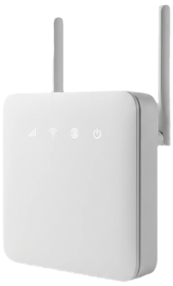
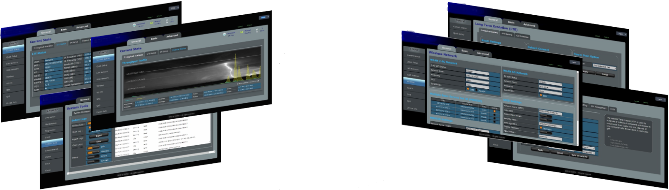
Interactive User Interface

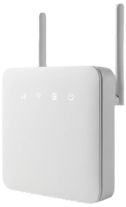
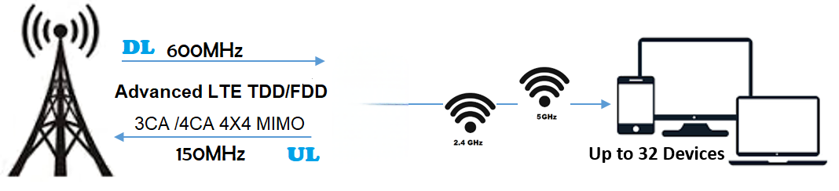
Technical Features
- Support Dual Mode LTE-TDD / LTE-FDD
- Support Dual Band Wi-Fi (2.4GHz / 5GHz) Concurrent
- Support Dual Stack IPv4 / IPv6
- Support Carrier Aggregation Combination (Inter / Intra)
- Support Category 12/15 (600Mbps Down Link, 150Mbps Up Link)
- Support 2 LAN ports, 1GE
- Support 1 WAN port
- Support Multi APN Management
- Support Multi SSID
- Support Short Message System
- Support Small Network Management Protocol (SNMP)
- Support CWMP TR069 and Certification (Primary and Secondary)
- Support Server Network Time protocol (SNTP).
- Support EARFCN lock, frequency lock, and PCI lock, PLMN lock, ICCID lock/
- Support two login access, root for administrator and admin for clients
- Support DDNS or DNS Agency
- Support WPS Soft Button and Push Button
- Support Routing (NAT, Tunnel, and Bridge Mode)
- Support VPN (L2TP, GRE, PPTP, VXLAN)
- Support IPSec VPN (Optional)
- Support UPS Battery for portability 6400mAh ~24 hour (Optional)
- Support Wi-Fi-Dog Solution (Optional)
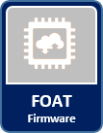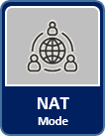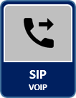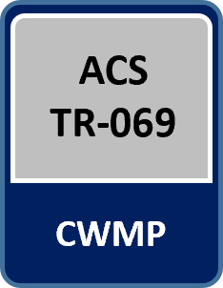
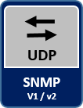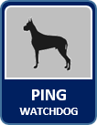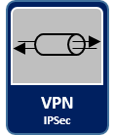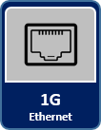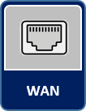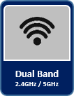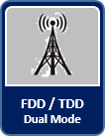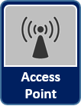
BASIC SPECIFICATIONS
LTE Standard | 3GPP latest Release, 8, 9, 10 & 11
Ethernet LAN/WAN Port | 1*RJ-45 port LAN 10/100/1000 auto-sensing,  1*RJ-45 port LAN / WAN
Smart Wi-Fi Dual Band | 2.4GHz (802.11 b/g/n and MIX)  5GHz (802.11 ac)
LED Indicators | 8 Blue LED indicators (PWR, Wi-Fi 2.4GHz, Wi-Fi 5GHz, LTE, RF and 4 Signal Level)
USIM | 1.8v/3.0v Mini-SIM (2FF)
RAM / Flash | 1Gb / 2Gb
Antenna | Wi-Fi: 2 Separate PCB Built-in high gain, 2.4GHz, 5GHz  LTE: 4 Separate internal 5dBi
Restore Button | Press for 10 Sec. to factory restore settings
Power Switch | ON/OFF Button
Wi-Fi Switch | ON/OFF Push button 15 Sec. hold
WPS Switch | ON/OFF Push button 10 Sec. hold
Front Panel LED | ON/OFF Push button
Power Supply | Input: Universal range 100V to 240V AC, Output 12VDC / 2A
Power Bank | Chargeable Battery and charging system (Optional)

LTE SPECIFICATIONS
Duplex Mode | Dual Mode (TDD Only, FDD Only TDD/FDD Mixed)
Support Bands | FDD Band: B1, B3, B7  TDD Band: B40, B42
Bandwidth | 1.4, 3, 5, 10, 15, 20MHz
Carrier Aggregation & MIMO | 2CA 4x4 MIMO  3CA / 4CA 2x2 MIMO
Max Output Power | 23 ± 2dBm per Tx antenna
Tx / Rx | 4T8R, 2T8R and 2T4R configurations
Uplink channel | PUCCH, PUSCH, PRACH
Downlink channel | PDCCH, PDSCH, PBCH, PCFICH, PHICH
Peak Rate (20 MHz) | FDD+TDD: DL 600 Mbps, UL 150 Mbps
Number of Resource Blocks | 6 ~ 110
Transmission Mode | TM 1.2,3,4,7,8,9
Modulation | DL: QPSK, 16QAM, 64QAM  UL: QPSK, 16QAM, 64QAM
Receive Sensitivity | -94dBm @ QPSK, 20 MHz, 25°C
Antenna Type | ABS
Antenna Gain | 5dBi
Antenna Efficiency | >60% or more
Polarization | Linear, Vertical
VSWR | 700~2700＜4 and 3300~3800＜3
Radiation | Omni-directional
Admitted Power | 1w
LTE RADIO STATUS INFORATION
General Info | USIM | Operator | EMM State
General Info | PLMN | eNodeB ID | RRC State
General Info | ICCID | Cell ID | TAC
General Info | IMSI | C-RNTI | ECI
Signal Details  &  Carrier Aggregation | PCI | EARFCN | Bandwidth
Signal Details  &  Carrier Aggregation | SINR | CINR | CQI
Signal Details  &  Carrier Aggregation | RSSI | RSRQ | RSRP
Signal Details  &  Carrier Aggregation | DL MCS | UL MCS | RANK
Signal Details  &  Carrier Aggregation | DL Frequency | DL Frequency | Band
Signal Details  &  Carrier Aggregation | Transfer mode | Intra Band | Inter Band
Signal Details  &  Carrier Aggregation | TXPWR | PCC | SCC (0,1,2,3)

SOFTWARE SPECIFICATIONS
LTE Network Mode | - NAT Mode  - Bridge Mode  - Tunnel Mode
LAN Network | - IPv4 address  - DHCP Statics Lease  - DHCP Relay  - DHCP Server, Client
Mobile Network Connection | - Auto  - Manual
4G LTE Connection | - Roam (Enable / Disable)  - Power Scan (First Detected Cell, Strongest Cell)  - Duplex Selection: (FDD/TDD Mixed), TDD Only. FDD Only  - Dedicated Mode: PCI, EARFCN, Frequency & Cell  - Cell Scan  - Neighbor Cell Auto Scan  - APN Management Settings
Wi-Fi (2.4GHz) | - Wi-Fi Enable / Disable  - Bandwidth: 20MHz / 40MHz  - Access Point Isolate  - Channel Selection: Manual, Auto  - Channel Range 1 ~ 13  - SSID: Hidden / Disable / Edit, Support four SSID  - Security type: No Authentication, WPA-PSK, WPA2-PSK, WPA/WPA2-PSK, WPA/WPA3-PSK  - WPA Algorithm: (TKIP/AES)  - WPS Enable / Disable  - Country Code: IRAN
Wi-Fi (5GHz) | - Wi-Fi Enable / Disable  - Bandwidth: 20MHz / 40MHz / 80MHz (Auto)  - Access Point Isolate  - Channel Selection: Manual, Auto  - Channel Range 36 ~ 64  - SSID: Hidden / Disable / Edit,  - Security type: No Authentication, WPA-PSK, WPA2-PSK, WPA/WPA2-PSK, WPA/WPA3-PSK  - WPA Algorithm: (TKIP/AES)  - Country Code: IRAN
WAN Network | - WAN (LTE)  - WAN (Input Access)
VPN Server | - IPsec  - L2TPv2 & v3  - GRE  - PPTP  - VxLAN L2/L3
Open NAT | - Port Range Forwarding  - Port Range Triggering  - DMZ Setting  - UPnP Setting  - ALG Rule Setting
Remote Access | - DDNS or DNS Agent  - SNMP
Firewall | - Terminal Firewall  - IPv4/IPv6 Filter (Black List / white List)  - MAC Filter (Black List / white List)  - URL Filter (Black List / white List)
System Security | - Remote Web Login  - Access Control  - Block Port scanner  - Block SYN Flood  - SPI Firewall
Terminal Security | - SSH  - Telnet
Device Management | - SNMP v3  - SAS
CWMP | - Primary TR069  - Certificated Primary  - Secondary TR069  - Certificated Secondary
Network Diagnostics | - TCP Dump  - Ping  - Traceroute  - iPerf
Administration | - Web Protocols (https 443 and http 80)  - NTP Setting  - MTU Setting  - PIN Management  - USIM Setting  - ICCID Setting
Statistics | - LTE Status  - System up time  - Device Status  - Firewall Status  - Roaming Status  - Carrier Aggregation Status
Network Users | - DHCP Client List  - Wi-Fi 2.4GHz Client List  - Wi-Fi 5GHz Client List
Maintenance | - Date and time setting  - Restore Factory Settings  - Backup Configuration file  - Firmware Upgrade locally Web UI  - Firmware Over The Air (FOTA)  - Ping Wi-Fi dog Setting
Routing | - Current Route Status  - Routing Map (ARP / Active Route)  - Static Routes (LAN / WAN / L3 VPN)  - Ping Watchdog
System Tools | - Operating Log (Info, Warnings, Errors, Critical)  - Run-time Log (Info, Warnings, Errors, Critical)  - Filter, Select, Display, export Logs
Debugging Software | - DM tools for troubleshooting
Other Applications | - WiFi-Dog Solution  - SMS Sent / Receive  - Calendar  - Events (IP Address Block, Reboot, WiFi, LTE)  - WPS Soft Button  - SSID Bind APN

Wi-Fi SPECIFICATIONS
Standards Supported | - 802.11b/g/n compatible Wi-Fi  - 802.11e QoS Enhancement (WMM)  - 802.11i (WPA, WPA2) No Authentication, shared key, and pair-wise key authentication services
Channel Bandwidth | 20MHz, 40MHz, 80MHz
Frequency 2.4GHz | 2.412 (Channel 1) ~ 2.472 (Channel 13)
Frequency 5GHz | 5.18 (Channel 36) ~ 5.32 (Channel 64)
TXRX | 2T2R
MIMO | 2x2 MIMO
Maximum Data Rate | - 802.11b: 11Mbps  - 802.11g: 54Mbps  - 802.11n: 300Mbps  - 802.11ac: 866Mbps
Modulation | - DSSS with DBPSK and DQPSK, CCK  - OFDM with BPSK, QPSK, 16QAM, and 64QAM
Convolutional Coding Rate: | 1/2, 2/3, 3/4, and 5/6
Receive Sensitivity | - -51dBm @ 135Mbps, typical for 802.11ac  - -64dBm @ 65Mbps, typical for 802.11n  - -65dBm @ 54Mbps, typical for 802.11g  - -76dBm @ 11Mbps, typical for 802.11b
Maximum Output Power | - 2.4GHz / 20dBm for ODFM & 18dBm for CCK modulation  - 5GHz / 23dBm
Fast Receiver | Automatic Gain Control (AGC)
Antenna Type | Build-in separate antenna, 2.4GHz, 5GHz
Antenna Gain | 2.4GHz / 3dBi  5GHz / 5dBi

ENVIRONMENTAL SPECIFICATIONS
Operating Temperature | -40°C to 55°C
Storage Temperature | -40°C to 70°C
Operating Humidity | 5% to 95%
Ingress Protection Rating | IP65

PACKAGE DELIVER
ITEMS | Assembled Product
ITEMS | Ethernet Cable, Cat5e
ITEMS | 12V/2A AC/DC Adaptor
ITEMS | Quick Installer Guide

Contact Information
Manufacture: crikleco Company
Address: AI Moosa Tower 2, Trade Center First, Dubai,UAE
EMail: info@crikleco.com

