Specification
4G LTE WiFi Gigabit Router

Plug & Play
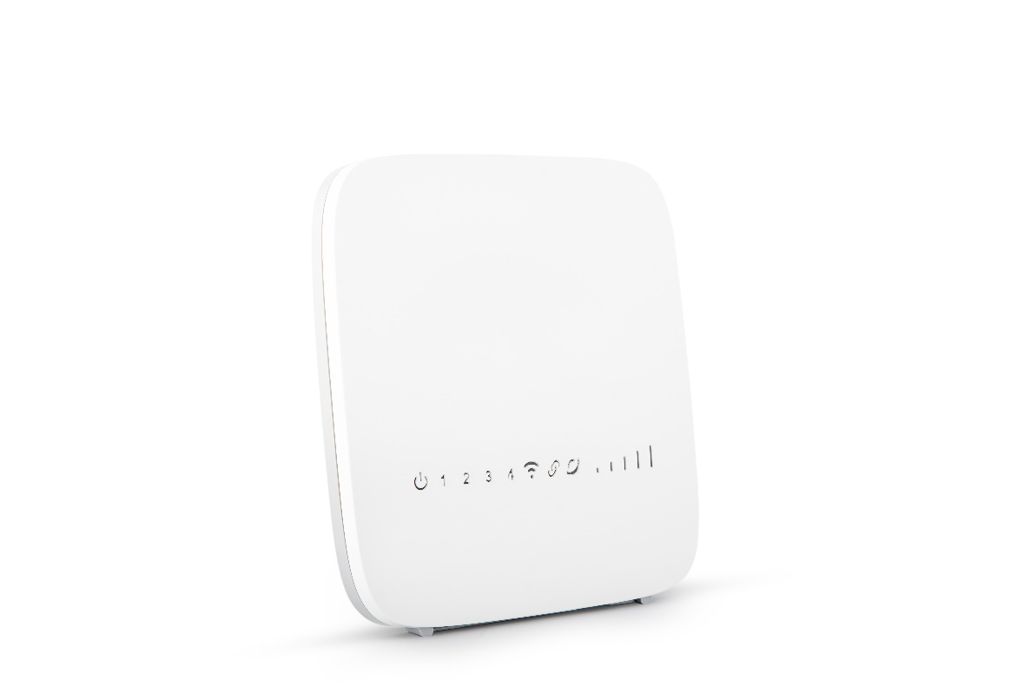
Model: BT44i

2X2 MIMO
T O R N A D O


Maintenance – Free Connections


Introduction

LTE (Long Term Evolution) is already gaining momentum as the world’s most rapidly deployed cellular technology, giving mobile wireless broadband services to millions of users worldwide. Consumers are increasingly looking for always on, always connected mobile experience delivering high data rate services on small factor mobile devices whilst at the same time expecting long battery life to minimize recharge cycles.
BT44i is Cat4 and 4G LTE indoor multi-service product solution for Enterprise and SHSO application. Specifically designed to meet integrated data, and dual bands Wi-Fi access needs for residential, business and home users.
In this product, we provide Gigabit networking and single bands Wi-Fi AP functionalities, it enables wide service coverage and provides high data throughput and networking features to customers who need easy broadband access and hot-spot Wi-Fi connectivity.

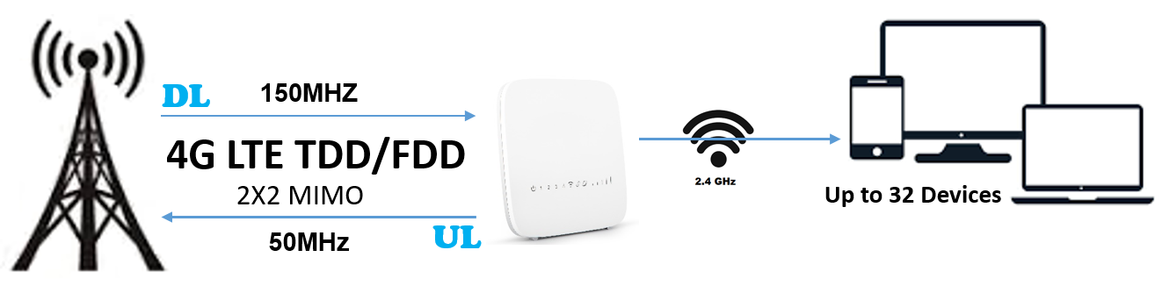

Technical Features
- Support 4 LAN ports, 1GE and include 1 WAN port
- Support Wi-Fi 2.4GHz Concurrent
- Support DMZ host Configuration
- Support Short Message System
- Support CWMP TR069 and Certification
- Support Server Network Time protocol & Time Synchronization (SNTP).
- Support EARFCN lock, PCI lock, PLMN lock, ICCID lock/
- Support two login access, root for administrator and admin for clients
- Support DDNS Agency
- Support WPS Soft Button and Push Button

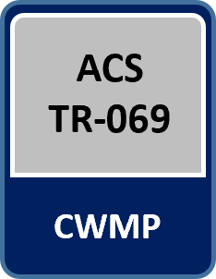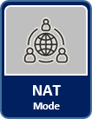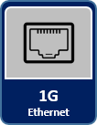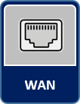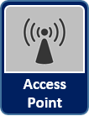

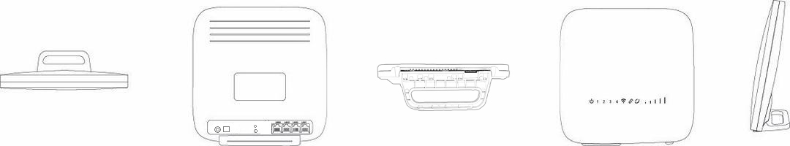
BASIC SPECIFICATIONS
Main Chipset | Quectel EC200AELV1
LTE Standard | 3GPP latest Release, 8, 9, 10 & 11
Ethernet LAN/WAN Port | 4*RJ-45 port LAN 10/100 auto-sensing,
Smart Wi-Fi Dual Mode | 2.4GHz (802.11 b/g/n and MIX)
LED Indicators | 8 Blue LED indicators (PWR, Wi-Fi 2.4GHz, LTE, RF and 4 Signal Level)
USIM | 1.8v/3.0v Mini-SIM (2FF)
Antenna | PCB Built-in high gain, 2.4GHz
Restore Button | Press for 10 Sec. to factory restore settings
Power Switch | ON/OFF Button
WPS Switch | ON/OFF Push button 10 Sec. hold
Power Supply | Input: Universal range 100V to 240V AC, Output 12VDC / 2A

LTE SPECIFICATIONS
Duplex Mode | FDD & TDD
Frequencies Bands | 4G LTE: B1, B3, B7, B8, B20, B38, B40, B41  3G WCDMA: B1, B5, B8
Bandwidth | 5, 10, 15, 20MHz
MIMO | 2x2 MIMO
Max Output Power | 23 ± 2dBm per Tx antenna
Tx / Rx | 1T2R configurations
Uplink Channel | PUCCH, PUSCH, PRACH
Downlink Channel | PDCCH, PDSCH, PBCH, PCFICH, PHICH
Peak Rate (20 MHz) | FDD: DL 150 Mbps, UL 50 Mbps  TDD: DL 130 Mbps, UL 30 Mbps
Number of Resource Blocks | 6 ~ 110
Transmission Mode | TM 1.2,3,4,7,8,9
Modulation | DL: QPSK, 16QAM, 64QAM  UL: QPSK, 16QAM
Receive Sensitivity | -96±2 dBm @QPSK, 20MHz, 25°C, -96±2 dBm @ 2RX Diversity
Antenna Type | PCB
Antenna Gain | 5dBi
Antenna Efficiency | >60% or more
Polarization | Linear, Vertical
VSWR | 700~2700＜4 and 3300~3800＜3
Radiation | Omni-directional
Admitted Power | 1w

LTE RADIO STATUS INFORATION
General Info | USIM | Operator | IMEI
General Info | PLMN | eNodeB ID | IMSI
Signal Details | PCI | EARFCN | Bandwidth
Signal Details | SINR | Band | Cell ID
Signal Details | RSSI | RSRQ | RSRP

SOFTWARE SPECIFICATIONS
LTE Network Mode | - NAT Mode
LAN Network | - IPv4 address  - DHCP Statics Lease  - DHCP Server, Client
Mobile Network Connection | - Auto  - Manual
4G LTE Connection | - Roam (Enable / Disable)  - Power Scan (First Detected Cell, Strongest Cell)  - Dedicated Mode: PCI, EARFCN, Frequency & Cell  - APN Management Settings
Wi-Fi (2.4GHz) | - Wi-Fi Enable / Disable  - Bandwidth: 20MHz / 40MHz  - Access Point Isolate  - Channel Selection: Manual, Auto  - Channel Range 1 ~ 11  - SSID: Hidden / Disable / Edit  - Security type: No Authentication, WPA-PSK, WPA2-PSK, WPA/WPA2-PSK,  - WPA Algorithm: (TKIP/AES)  - WPS Enable / Disable  - Country Code: Lock IRAN
WAN Network | - WAN (LTE)  - WAN (Input Access)
Data Services | - Port Range Forwarding  - Port Range Triggering  - DMZ Setting
Remote Access | - DDNS or DNS Agent
Security | - Terminal Firewall  - IPv4 Filter  - MAC Filter  - WAN Filter  - Port Triggering Filter  - Port Forwarding Filter
System | - Remote Web Login  - Access Control  - Ping Watchdog
Terminal Security | - SSH  - Telnet
CWMP | - Primary TR069  - Certificated Primary
Network Diagnostics | - Ping  - Traceroute
Administration | - Web Protocols (https 443 and http 80)  - NTP Setting  - MTU Setting  - PIN Management  - USIM Setting  - ICCID Setting
Statistics | - LTE Status  - System up time  - Device Status  - Firewall Status  - Roaming Status
Network Users | - DHCP Client List  - Wi-Fi 2.4GHz Client List
Maintenance | - Date and time setting  - Restore Factory Settings  - Backup Configuration file  - Firmware Upgrade locally Web UI
Other Applications | - SMS Sent / Receive  - WPS Soft Button

Wi-Fi SPECIFICATIONS
Standards Supported | - 802.11b/g/n compatible Wi-Fi  - 802.11e QoS Enhancement (WMM)  - 802.11i (WPA, WPA2) No Authentication, shared key, and pair-wise key authentication services
Channel Bandwidth | 20MHz, 40MHz
Frequency 2.4GHz | 2.412 (Channel 1) ~ 2.462 (Channel 11)
TXRX | 1T2R
MIMO | 2x2 MIMO
Maximum Data Rate | - 802.11b: 11Mbps  - 802.11g: 54Mbps  - 802.11n: 300Mbps
Modulation | - DSSS with DBPSK and DQPSK, CCK  - OFDM with BPSK, QPSK, 16QAM
Convolutional Coding Rate: | 1/2, 2/3, 3/4, and 5/6
Receive Sensitivity | - -64dBm @ 65Mbps, typical for 802.11n  - -65dBm @ 54Mbps, typical for 802.11g  - -76dBm @ 11Mbps, typical for 802.11b
Maximum Output Power | - 20dBm for ODFM & 18dBm for CCK modulation
Fast Receiver | Automatic Gain Control (AGC)
Antenna Type | Build-in separate antenna, 2.4GHz
Antenna Gain | 2.4GHz / 3dBi

ENVIRONMENTAL SPECIFICATIONS
Operating Temperature | -40°C to 55°C
Storage Temperature | -40°C to 70°C
Operating Humidity | 5% to 95%
Ingress Protection Rating | IP65

PACKAGE DELIVER
Assembled Product
Ethernet Cable, Cat5
12V/2A AC / DC Adaptor
Quick Installer Guide

Contact Information
Manufacture: crikleco Company
Address: AI Moosa Tower 2, Trade Center First, Dubai,UAE
EMail: info@crikleco.com

