Specification
GPON Wi-Fi Gigabit Router
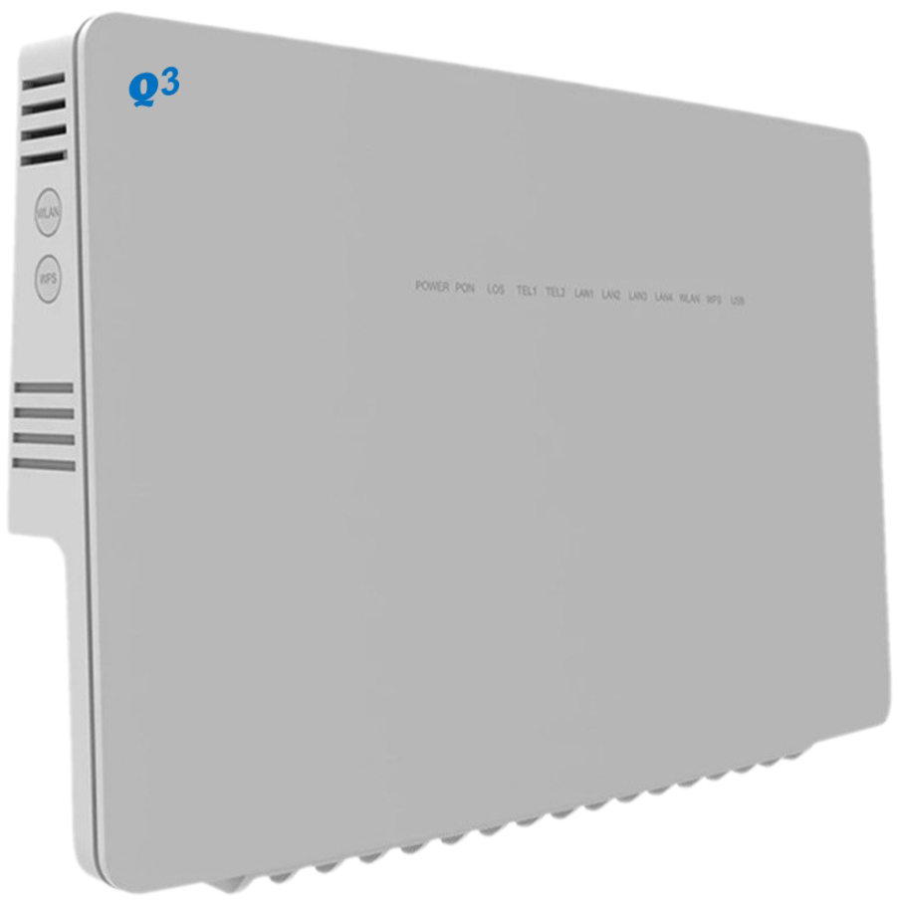
Model: BTQ34i
F I B E R T O R N A D O 1

Maintenance – Free Connections


Introduction

BTQ34i is for broadband access market based on the introduction of EPON & GPON technology passive optical network terminal products. It’s with EPON/GPON OLT are used together to provide a complete broadband access solution.
This model can integrate wireless function with meeting 802.11 n/b/g/ac technical standards, It has built‐in high gain directional antenna, the wireless transmission rate up to 866Mbps. It has the characteristics of strong penetrating power and wide coverage. It can provide users with more efficient data transmission security.
BTQ34i is highly advanced GPON indoor multi-service product solution for Enterprise and SHSO application. Specifically designed to meet integrated data, and dual bands Wi-Fi access needs for residential, business and enterprise users.
In this product, we provide Gigabit networking and dual bands Wi-Fi AP functionalities, it enables wide service coverage and provides high data throughput and networking features to customers who needs easy broadband access, hot-spot Wi-Fi connectivity.

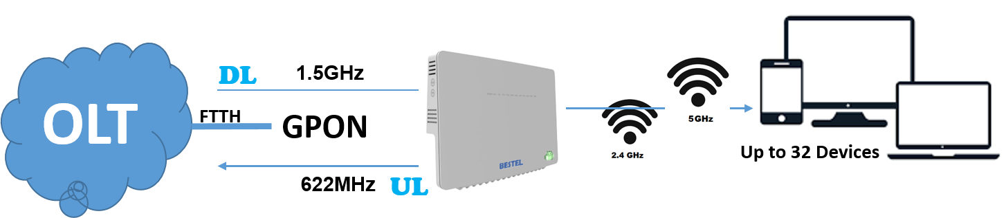

Technical Features
- Support Dual Band Wi-Fi (2.4GHz / 5GHz) Concurrent
- Support Dual Stack IPv4 / IPv6
- Support 4 LAN ports, 1GE
- Support 1 WAN port
- Support 1 SIP line
- Support Access Point Only
- Support Small Network Management Protocol (SNMP)
- Support CWMP TR069 and Certification
- Support Server Network Time protocol (SNTP).
- Support two login access, root for administrator and admin for clients
- Support WPS Soft Button
- Support Routing (NAT, Tunnel, and Bridge Mode)
- Support VPN (L2TP, GRE, PPTP)
- Support 1 USB Storage


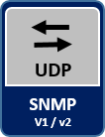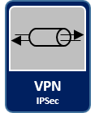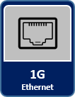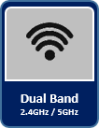

GPON Specfications

Standard | FSAN G.984.2, Class B+
Authentication | Consistent with the SN or password
Downstream | 2.488Gbps
Upstream | 1.244Gbps
Receiver Sensitivity | -28dBm
Transmit Optical Power | 0.5~5dBm
Saturation Optical Power | -8dBm
Wavelength Transmitter | 1310nm
Wavelength Receiver | 1490nm

EPON Specfications

Standard | 1000BASE-PX20+ Symmetric CTC2.1, CTC3.0
Authentication | Consistent with the MAC or LOID
Downstream | 1.25Gbps
Upstream | 1.25Gbps
Receiver Sensitivity | -27dBm
Transmit Optical Power | 0~4dBM
Saturation Optical Power | -3dBm
Wavelength Transmitter | 1310nm
Wavelength Receiver | 1490nm

ONT SPECIFICATIONS

GPON Standard | ITU-T G.984.X
Dimensions (L x W x H) | 265mm x 16mm x 32mm
Weight | TDB
Wi-Fi Dual Band | 2.4GHz (802.11 b/g/n and MIX)  5GHz (802.11 ac)
Wi-Fi Antenna | 2 Separate PCB Built-in high gain, 2.4GHz, 5GHz
LED Indicators | WPS٫WLAN٫LAN4٫LAN3٫LAN2٫LAN1٫USB٫TEL٫LOS٫PON
UNI | 1POT + 4GE + 2.4G/5G Wi-Fi + 1USB
Restore Button | Press for 10 Sec. to factory restore settings
ONT Power Switch | ON/OFF Push Button
Power Supply | Input: Universal range 100V to 240V AC, Output DC 12V/2A
Static power consumption | 3W
Maximum power consumption | 10W
Installation mode | DESKTOP, WALL MOUNT

port specfications

Fiber Port | SC/PC single-mode fiber
Fiber Port | Flexible mapping between GEM Port and TCONT
Fiber Port | Bi-directional FEC
Fiber Port | SR-DBA and NSR-DBA
Fiber Port | Type B (Single-homing & Dual-homing)
Ethernet Port | Ethernet port-based VLAN tags and tag removal
Ethernet Port | 1:1 VLAN, N:1 VLAN or VLAN transparent transmission
Ethernet Port | QinQ VLAN
Ethernet Port | Limit on the number of learned MAC addresses
Ethernet Port | Auto-adaptive 10 Mbit/s, 100 Mbit/s or 1000 Mbit/s
Ethernet Port | Full/half duplex mode, auto MDI/MDI-X
POTS Port (Optional) | Maximum REN:4
POTS Port (Optional) | G.711A/µ, G.729a/b & G.722 encoding/decoding
POTS Port (Optional) | T.30/T.38/G.711 Fax mode
POTS Port (Optional) | DTMF, Emergency calls (with the SIP protocol)
USB Port | USB 2.0 interface
USB Port | Transmission Rate 480Mbps
USB Port | FTP-based network storage
USB Port | File/Print sharing basted on SAMRA
USB Port | DLNA function
WLAN | Comply with IEEE 802.11a/b/g/n/ac protocol standard
WLAN | 5dBi antenna gain
WLAN | Maximum ideal rate up to 1.2Gbps
WLAN | 2.4GHz supports 2*2 MIMO technology
WLAN | 5GHz supports 2*2 MIMO technology
WLAN | WMM/Multiple SSIDs/WPS

SOFTWARE SPECIFICATIONS

LAN Network | - IPv4 address  - DHCP Statics Lease  - DHCP Relay  - DHCP Server, Client
Wi-Fi (2.4GHz) | - Wi-Fi (Enable / Disable)  - Frequency Range: 2.412GHz ~ 2.462GHz  - Bandwidth: 20MHz / 40MHz  - Access Point Isolate  - Channel Mode: Manual, Auto  - Channel Range 1 ~ 13 (Europe)  - SSID: Hidden / Disable / Edit, Support four SSID  - Security type: No Authentication, WPA-PSK, WPA2-PSK, WPA/WPA2-PSK, WPA3-PSK  - WPA Algorithm: (TKIP/AES)  - WPS Enable / Disable  - Country Code: IRAN
Wi-Fi (5GHz) | - Wi-Fi (Enable / Disable)  - Frequency Range: 5.18GHz ~ 5.7GHz  - Bandwidth: 20MHz / 40MHz / 80MHz (Auto)  - Access Point Isolate  - Channel Mode: Manual, Auto  - Channel Range 36 ~ 64 (Europe)  - SSID: Hidden / Disable / Edit,  - Security type: No Authentication, WPA-PSK, WPA2-PSK, WPA/WPA2-PSK, WPA3-PSK  - WPA Algorithm: (TKIP/AES)  - Country Code: IRAN
WAN Network | - WAN (Input Access)
VPN Server | - IPsec  - L2TPv2 & v3  - PPTP
Data Services | - Port Range Forwarding  - Port Range Triggering  - DMZ Setting  - UPnP Setting  - ALG Setting
Remote Access | - DDNS or DNS Agent  - SNMP
Firewall | - Terminal Firewall (Enable / Disable)  - IPv4/IPv6 Filter (Black List / white List)  - MAC Filter (Black List / white List)  - URL Filter (Black List / white List)
System Security | - Remote Web Login  - Access Control  - Block Port scanner  - SPI Firewall
Terminal Security | - SSH  - Telnet
Device Management | - SNMP v3  - SAMBA Service
CWMP | - Primary TR069
Network Diagnostics | - Ping  - Traceroute
Administration | - Web Protocols (https 443 and http 80)  - NTP Setting
Network Users | - DHCP Client List  - Wi-Fi 2.4GHz Client List  - Wi-Fi 5GHz Client List
Maintenance | - Date and time setting  - Restore Factory Settings  - Backup Configuration file  - Firmware Upgrade locally Web UI  - Firmware Over The Air (FOTA)

Wi-Fi SPECIFICATIONS

Standards Supported | - 802.11b/g/n compatible Wi-Fi  - 802.11e QoS Enhancement (WMM)  - 802.11i (WPA, WPA2) No Authentication, shared key, and pair-wise key authentication services
Channel Bandwidth | 20MHz, 40MHz, 80MHz
Frequency 2.4GHz | 2.412 (Channel 1) ~ 2.472 (Channel 13)
Frequency 5GHz | 5.18 (Channel 36) ~ 5.32 (Channel 64)
TXRX | 2T2R
MIMO | 2x2 MIMO
Maximum Data Rate | - 802.11b: 11Mbps  - 802.11g: 54Mbps  - 802.11n: 300Mbps  - 802.11ac: 866Mbps
Modulation | - DSSS with DBPSK and DQPSK, CCK  - OFDM with BPSK, QPSK, 16QAM, and 64QAM
Convolutional Coding Rate: | 1/2, 2/3, 3/4, and 5/6
Receive Sensitivity | - -51dBm @ 135Mbps, typical for 802.11ac  - -64dBm @ 65Mbps, typical for 802.11n  - -65dBm @ 54Mbps, typical for 802.11g  - -76dBm @ 11Mbps, typical for 802.11b
Maximum Output Power | - 2.4GHz / 20dBm for ODFM & 18dBm for CCK modulation  - 5GHz / 23dBm
Fast Receiver | Automatic Gain Control (AGC)
Antenna Type | Build-in separate antenna, 2.4GHz, 5GHz
Antenna Gain | 2.4GHz / 3dBi  5GHz / 5dBi

ENVIRONMENTAL SPECIFICATIONS

Operating Temperature | 0℃~45℃
Standby Temperature | -40℃~70℃
Operating Humidity | 10% - 90%
Standby Humidity | 5% - 90% RH

PACKAGE DELIVER

Assembled Product
Quick Installer Guide
Remote Controller
Ethernet Cable, Cat5
HDMI Cable
12V-2A AC / DC Adaptor
2 x AAA 1.5v Battery

Contact Information
Manufacture: crikleco Company
Address: AI Moosa Tower 2, Trade Center First, Dubai,UAE
EMail: info@crikleco.com

