Specification
GPON Wi-Fi Gigabit Router
Smart TV BOX
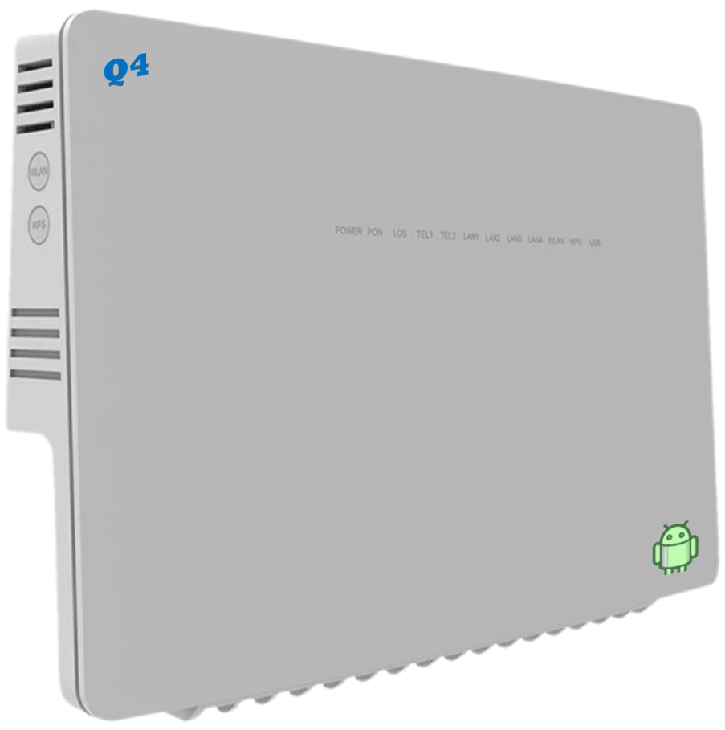
Model: BTQ43i
S M A R T F I B E R T O R N A D O

Maintenance – Free Connections


Introduction
BTQ43i is for broadband access market based on the introduction of EPON & GPON technology passive optical network terminal products. It’s with EPON/GPON OLT are used together to provide a complete broadband access solution.
This model can integrate wireless function with meeting 802.11 n/b/g/ac technical standards, It has built‐in high gain directional antenna, the wireless transmission rate up to 866Mbps. It has the characteristics of strong penetrating power and wide coverage. It can provide users with more efficient data transmission security.
BTQ43i is highly advanced GPON indoor multi-service product solution for Enterprise and SHSO application. Specifically designed to meet integrated data, and dual bands Wi-Fi access needs for residential, business and enterprise users.
In this product, we provide Gigabit networking and dual bands Wi-Fi AP functionalities, it enables wide service coverage and provides high data throughput and networking features to customers who needs easy broadband access, hot-spot Wi-Fi connectivity.
The device also have Smart TV Box, VoIP and USB interface support.

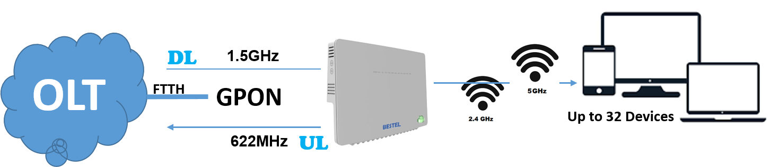

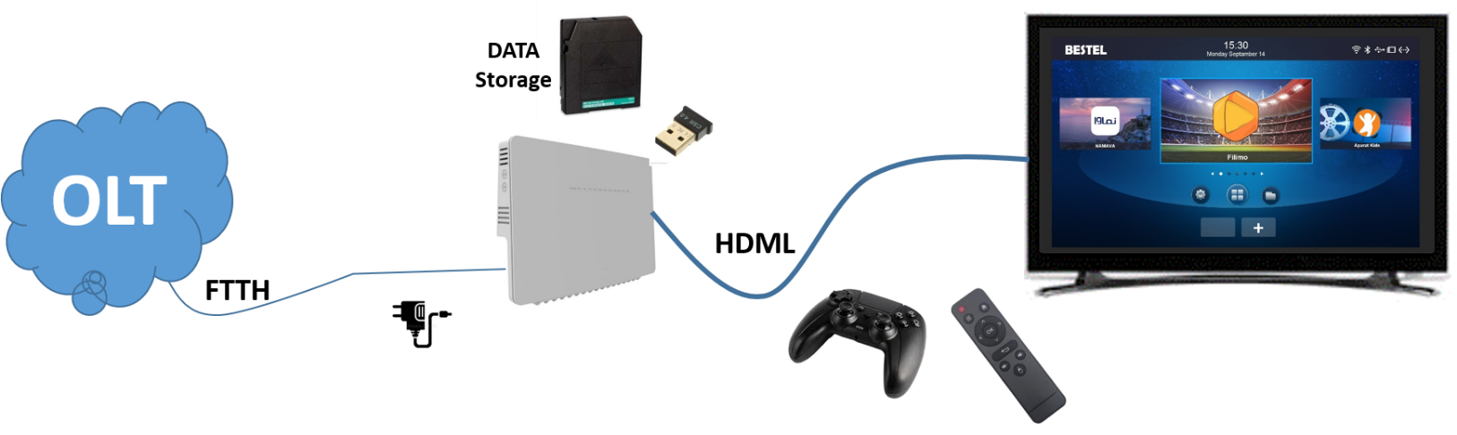

Technical Features
- Support Dual Band Wi-Fi (2.4GHz / 5GHz) Concurrent
- Support Dual Stack IPv4 / IPv6
- Support 3 LAN ports, 1GE
- Support 1 WAN port
- Support Small Network Management Protocol (SNMP)
- Support CWMP TR069 and Certification (Primary and Secondary)
- Support Server Network Time protocol (SNTP).
- Support two login access, root for administrator and admin for clients
- Support DDNS or DNS Agency
- Support WPS Soft Button
- Support Routing (NAT, Tunnel, and Bridge Mode)
- Support VPN (L2TP, GRE, PPTP)
- Support IPSec VPN

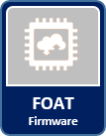
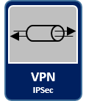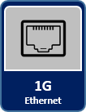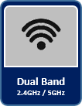

GPON Specfications

Standard | FSAN G.984.2, Class B+
Authentication | Consistent with the SN or password
Downstream | 2.488Gbps
Upstream | 1.244Gbps
Receiver Sensitivity | -28dBm
Transmit Optical Power | 0.5~5dBm
Saturation Optical Power | -8dBm
Wavelength Transmitter | 1310nm
Wavelength Receiver | 1490nm

EPON Specfications

Standard | 1000BASE-PX20+ Symmetric CTC2.1, CTC3.0
Authentication | Consistent with the MAC or LOID
Downstream | 1.25Gbps
Upstream | 1.25Gbps
Receiver Sensitivity | -27dBm
Transmit Optical Power | 0~4dBM
Saturation Optical Power | -3dBm
Wavelength Transmitter | 1310nm
Wavelength Receiver | 1490nm

ONT SPECIFICATIONS

GPON Standard | ITU-T G.984.X
Dimensions (LxWxH) | 265mm x 16mm x 32mm
Weight | TDB
Wi-Fi Dual Band | 2.4GHz (802.11 b/g/n and MIX)  5GHz (802.11 ac)
Wi-Fi Antenna | 2 Separate PCB Built-in high gain, 2.4GHz, 5GHz
LED Indicators | WPS٫WLAN٫LAN4٫LAN3٫LAN2٫LAN1٫USB٫TEL٫LOS٫PON٫ONT٫OTT
UNI | 1POT + 3GE + 2.4G/5G Wi-Fi + 3USB + 1HDMI + 1AV OUT + 1IR Receiver
Restore Button | Press for 10 Sec. to factory restore settings
ONT Power Switch | ON/OFF Button
OTT Power Switch | ON/OFF Button
Power Supply | Input: Universal range 100V to 240V AC, Output DC 12V/3A
Static power consumption | 3W
Maximum power consumption | 10W
Installation mode | DESKTOP, WALL MOUNT

port specfications

Fiber Port | SC/PC single-mode fiber
Fiber Port | Flexible mapping between GEM Port and TCONT
Fiber Port | Bi-directional FEC
Fiber Port | SR-DBA and NSR-DBA
Fiber Port | Type B (Single-homing & Dual-homing)
Ethernet Port | Ethernet port-based VLAN tags and tag removal
Ethernet Port | 1:1 VLAN, N:1 VLAN or VLAN transparent transmission
Ethernet Port | QinQ VLAN
Ethernet Port | Limit on the number of learned MAC addresses
Ethernet Port | Auto-adaptive 10 Mbit/s, 100 Mbit/s or 1000 Mbit/s
Ethernet Port | Full/half duplex mode, auto MDI/MDI-X
POTS Port (Optional) | Maximum REN:4
POTS Port (Optional) | G.711A/µ, G.729a/b & G.722 encoding/decoding
POTS Port (Optional) | T.30/T.38/G.711 Fax mode
POTS Port (Optional) | DTMF, Emergency calls (with the SIP protocol)
USB Port | USB 2.0 interface
USB Port | Transmission Rate 480Mbps
USB Port | FTP-based network storage
USB Port | File/Print sharing basted on SAMRA
USB Port | DLNA function
WLAN | Comply with IEEE 802.11a/b/g/n/ac protocol standard
WLAN | 5dBi antenna gain
WLAN | Maximum ideal rate up to 1.2Gbps
WLAN | 2.4GHz supports 2*2 MIMO technology
WLAN | 5GHz supports 2*2 MIMO technology
WLAN | WMM/Multiple SSIDs/WPS
HDMI Port | 4K*2K UHD Output, HDMI 2.0A
AV Port | 480i/576i standard definition output
AV Port | Remote Receiver Connection

SOFTWARE SPECIFICATIONS

LAN Network | - IPv4 address  - DHCP Statics Lease  - DHCP Relay  - DHCP Server, Client
Wi-Fi (2.4GHz) | - Wi-Fi (Enable / Disable)  - Frequency Range: 2.412GHz ~ 2.462GHz  - Bandwidth: 20MHz / 40MHz  - Access Point Isolate  - Channel Mode: Manual, Auto  - Channel Range 1 ~ 13 (Europe)  - SSID: Hidden / Disable / Edit, Support four SSID  - Security type: No Authentication, WPA-PSK, WPA2-PSK, WPA/WPA2-PSK, WPA3-PSK  - WPA Algorithm: (TKIP/AES)  - WPS Enable / Disable  - Country Code: IRAN
Wi-Fi (5GHz) | - Wi-Fi (Enable / Disable)  - Frequency Range: 5.18GHz ~ 5.7GHz  - Bandwidth: 20MHz / 40MHz / 80MHz (Auto)  - Access Point Isolate  - Channel Mode: Manual, Auto  - Channel Range 36 ~ 64 (Europe)  - SSID: Hidden / Disable / Edit,  - Security type: No Authentication, WPA-PSK, WPA2-PSK, WPA/WPA2-PSK, WPA3-PSK  - WPA Algorithm: (TKIP/AES)  - Country Code: IRAN
WAN Network | - WAN (Input Access)
VPN Server | - IPsec  - L2TPv2 & v3  - PPTP
Data Services | - Port Range Forwarding  - Port Range Triggering  - DMZ Setting  - UPnP Setting  - ALG Setting
Remote Access | - DDNS or DNS Agent  - SNMP
Firewall | - Terminal Firewall (Enable / Disable)  - IPv4/IPv6 Filter (Black List / white List)  - MAC Filter (Black List / white List)  - URL Filter (Black List / white List)
System Security | - Remote Web Login  - Access Control  - Block Port scanner  - SPI Firewall
Terminal Security | - SSH  - Telnet
Device Management | - SNMP v3  - SAMBA Service
CWMP | - Primary TR069
Network Diagnostics | - Ping  - Traceroute
Administration | - Web Protocols (https 443 and http 80)  - NTP Setting
Network Users | - DHCP Client List  - Wi-Fi 2.4GHz Client List  - Wi-Fi 5GHz Client List
Maintenance | - Date and time setting  - Restore Factory Settings  - Backup Configuration file  - Firmware Upgrade locally Web UI  - Firmware Over The Air (FOTA)

Wi-Fi SPECIFICATIONS

Standards Supported | - 802.11b/g/n compatible Wi-Fi  - 802.11e QoS Enhancement (WMM)  - 802.11i (WPA, WPA2) No Authentication, shared key, and pair-wise key authentication services
Channel Bandwidth | 20MHz, 40MHz, 80MHz
Frequency 2.4GHz | 2.412 (Channel 1) ~ 2.472 (Channel 13)
Frequency 5GHz | 5.18 (Channel 36) ~ 5.32 (Channel 64)
TXRX | 2T2R
MIMO | 2x2 MIMO
Maximum Data Rate | - 802.11b: 11Mbps  - 802.11g: 54Mbps  - 802.11n: 300Mbps  - 802.11ac: 866Mbps
Modulation | - DSSS with DBPSK and DQPSK, CCK  - OFDM with BPSK, QPSK, 16QAM, and 64QAM
Convolutional Coding Rate: | 1/2, 2/3, 3/4, and 5/6
Receive Sensitivity | - -51dBm @ 135Mbps, typical for 802.11ac  - -64dBm @ 65Mbps, typical for 802.11n  - -65dBm @ 54Mbps, typical for 802.11g  - -76dBm @ 11Mbps, typical for 802.11b
Maximum Output Power | - 2.4GHz / 20dBm for ODFM & 18dBm for CCK modulation  - 5GHz / 23dBm
Fast Receiver | Automatic Gain Control (AGC)
Antenna Type | Build-in separate antenna, 2.4GHz, 5GHz
Antenna Gain | 2.4GHz / 3dBi  5GHz / 5dBi

OTT SPECIFICATIONS

Video |  | All winner Video Engine (AVE) with dedicated hardware decoders and encoders
 |  | Support multi-video decoder up to 4K@60fps
 |  | Supports multiple "secured" video decoding sessions and simultaneous decoding and encoding
 |  | Video/Picture Decoding
Video/Picture Decoding |  | VP9 Profile-2 up to 4K@30fps
 |  | H.265 Mam10@1.5.1 up to 4K@60fps
 |  | AVS2 JiZhum 10bit Profile up to 4K@60fps
 |  | H.264 BP/MP/HP@L4.2 up to 4K@30fps
 |  | H.263 BP up to 1080P@60fps
 |  | MPEG-4 SP/ASP@L5 up to 1080P@60fps
 |  | MPEG-2 MP/HI up to 1080P@60fps
 |  | MPEG-1 MP/HI up to 1080P@60fps
 |  | Xvid ap to 1080P@60fps
 |  | Sorenson Spark up to 1080P@60fps
 |  | VP8 up to 1080P@60fps
 |  | AVS/AVS+ JiZhun Profile up to 1080P@60fps
 |  | WMV9٫VCI SP/MP/AP up to 1080P@60fps
 |  | JPEG IFIF file format up to 45M PPS
 |  | Multiple language and multiple format sub-title video support
 |  | MJPEG and JPEG unlimited pixel resolution decoding (ISO/IEC-10918)
 |  | Supports JPEG thumbnail, scaling, rotation and transition effects
 |  | Supports *mkv. *.wmv, *.mpg*.mpeg, *.dat, *.avi, *mov, *iso, *.mp4, *.rm and ".jpg file formats.
Image |  | HD JPEG, BMP GIF. PNG. TIF
language |  | English French German Spanish Italian etc. multilateral languages
OS |  | Android 10.0
Audio |  | Supports MP3, AAC, WMA, RM, FLAC, Ogg and programmable with 7.1/5.1 down-mixing
 |  | Built-in serial digital audio SPDIF/IEC958 input/output and PCM input/output
 |  | Two DAC channels
 |  | Supports 1 audio output interface (differential LINEOUTP/N or single-end LINEOUTL/LINFOUTR)
 |  | One Audio HUB, supporting internal mixing function
 |  | Embedded 3 I2S/PCM (12S0 for extended audio codec. 12S2 for BT, 12S3 for digital power amplifier)
 |  | Supports Left-justified, Right-justified, Standard 12S mode. PCM mode, and TDM mode
 |  | 125 mode supports 8 channels, and 32-bit/192kbit sample rate
 |  | 125 and TDM modes support maximum 16 channels, and 32- bit٫96kbit sample rate
 |  | One OWA OUT interface, supporting 16-/20-/24-bit inputs and outputs
 |  | Integrated digital microphone (DMIC), supporting maximum 8 digital PDM microphones
Applications | Online | Browse all video websites, support Netflix, Hulu, Flixster, Youtube, etc.
Applications | Apps | Apps download freely form android market amazon app store etc.
Applications | Talk online | Support SKYPE video call MSN, facebook, Twitter. QQ etc.
Applications | Medium | Local Media playback. Support HDD, U Disck, TF Card.
Applications | Others | Support Email, office suit etc.
Applications | Others | Support DLNA function
Applications | Others | Support 2.4G wireless mouse/keyboard

ENVIRONMENTAL SPECIFICATIONS

Operating Temperature | 0℃~45℃
Standby Temperature | -40℃~70℃
Operating Humidity | 10% - 90%
Standby Humidity | 5% - 90% RH

PACKAGE DELIVER

Assembled Product
Quick Installer Guide
Remote Controller
Ethernet Cable, Cat5
HDMI Cable
12V-3A AC / DC Adaptor
2 x AAA 1.5v Battery
SC – SC patch cord

Contact Information
Manufacture: crikleco Company
Address: AI Moosa Tower 2, Trade Center First, Dubai,UAE
EMail: info@crikleco.com

